Questions.

Q1A)

what is the five-number summary of the data.

> ##five num summary displays five num summaray  
> ##or we can use summary like the pdf request  
> summary(roulette)  
 Min. 1st Qu. Median Mean 3rd Qu. Max.   
 5.0 6.0 9.0 11.8 15.0 55.0

Minimum capital = 5.0, (0 successful bets)

1st Quartile = 6.0, (1 successful bets)

Median = 9.0, (3 successful bets)

3rd Quartile = 15.0, (10 successful bets)

Max Capital = 55.0, (50 successful bets)

Q1B)

> summary(roulette)[2]-1.5\*IQR(roulette)  
1st Qu.   
 -7.5   
> summary(roulette)[5]+1.5\*IQR(roulette)  
3rd Qu.   
 28.5   
> #outer fences of the IQR  
> summary(roulette)[2]-3\*IQR(roulette)  
1st Qu.   
 -21   
> summary(roulette)[5]+3\*IQR(roulette)  
3rd Qu.   
 42

Calculate the IQR and the locations of the inner and outer fences to identify outliers &  
extreme outliers. Submit the R output for the IQR, inner & outer fences. Then clearly  
explain if there are any outliers and extreme outliers based on the values of the output

Any outliers of the IQR are numbers where people made more than 42 dollars, or 35 successful one-dollar belts.

Some outlier values were 55 and 45.

Q1C)

draw a box plot that shows the fences, suspected outliers, and outliers. (Must draw using R  
only.)

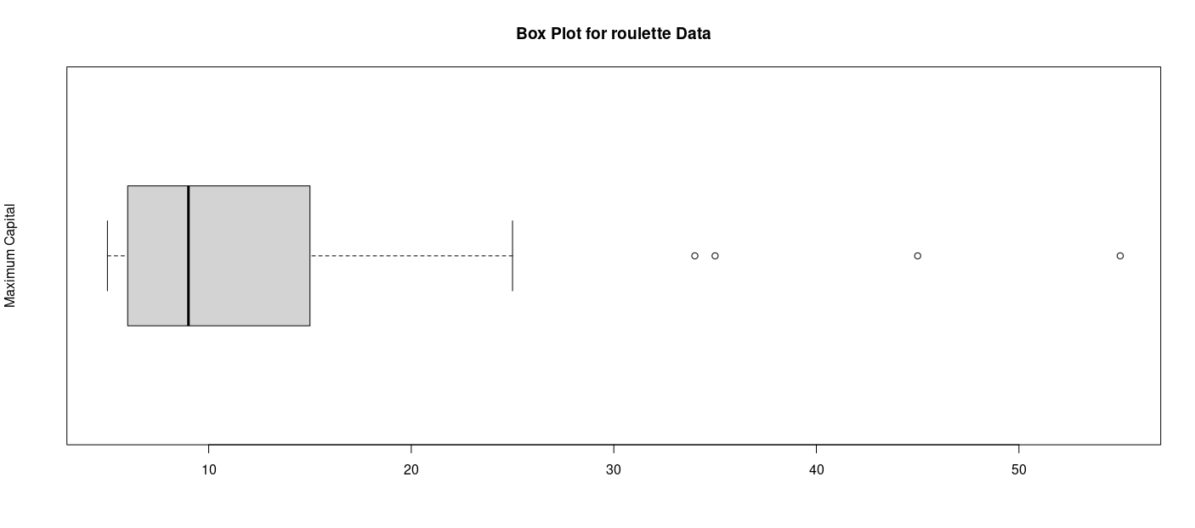Q2A) Find the frequencies 0, 1, 2,,8.

> ##calculating the question of 0, 1 , 2, ..8  
> table(gamma)  
gamma  
 0 1 2 3 4 5 6 7 8   
17 47 63 63 49 28 21 11 1

Q2B)

calculate the sample mean and sample variance. Are they approximately equal

> #calculate the sample mean and sample variance  
> mean(gamma)  
[1] 3.03  
> var(gamma)  
[1] 3.193077

Sample mean = 3.03,

Sample Variability = 3.193

They are similar but I would not say they are equal, when compared to lambda 3 we can see a trend but the variability is a pretty significant margin of error different than the mean.

Q3B)

Construct a probability histogram with λ = 3 and a relative frequency histogram on the same  
graph. Graph must be drawn using R only.

Probability Histogram:

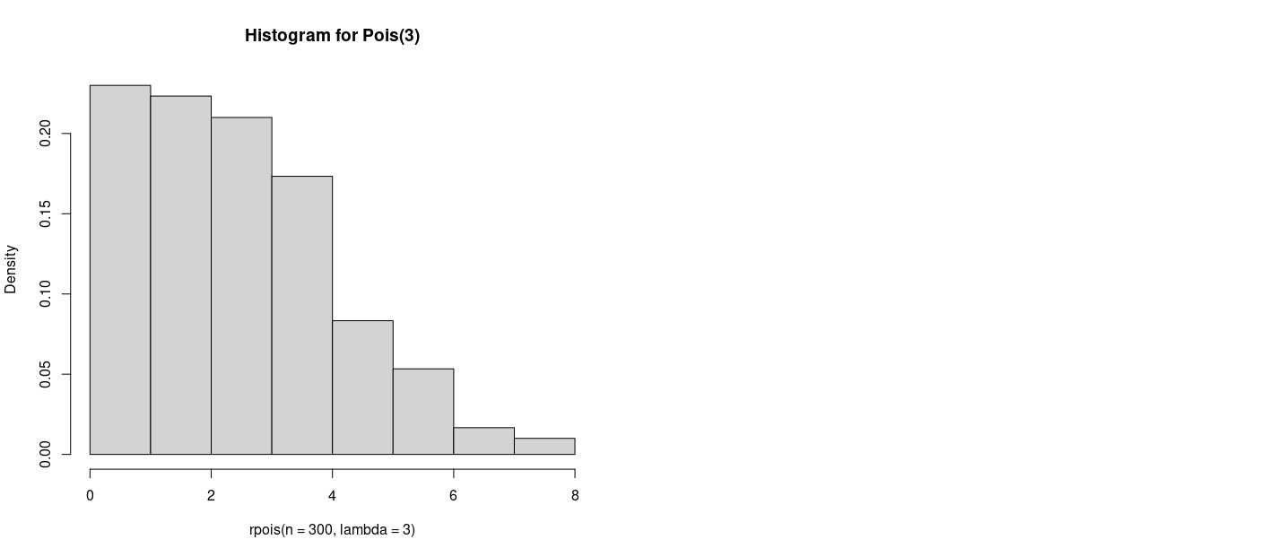

Relative Frequency: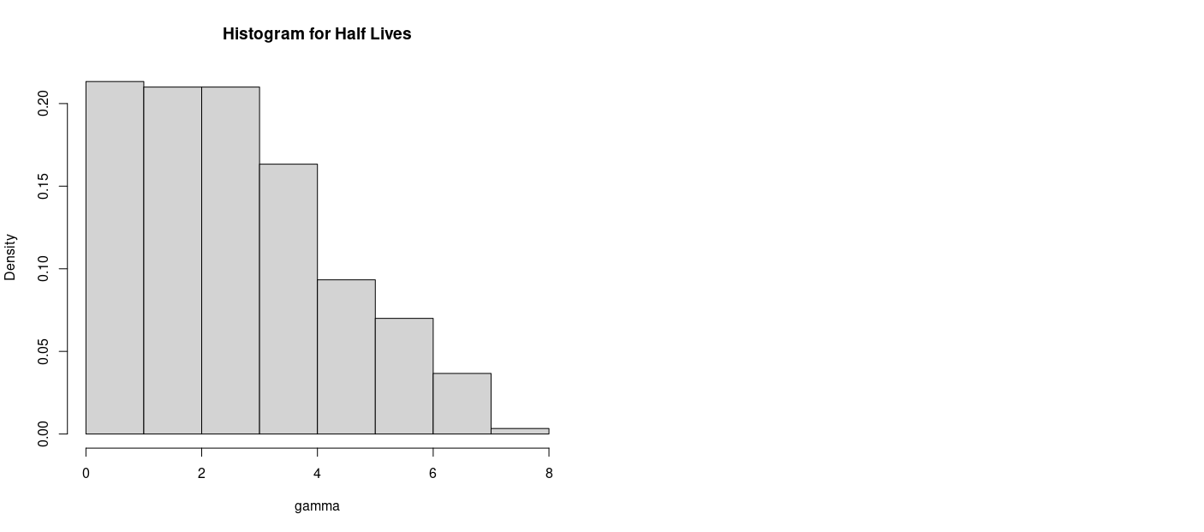

Q4B) What is your conclusion?

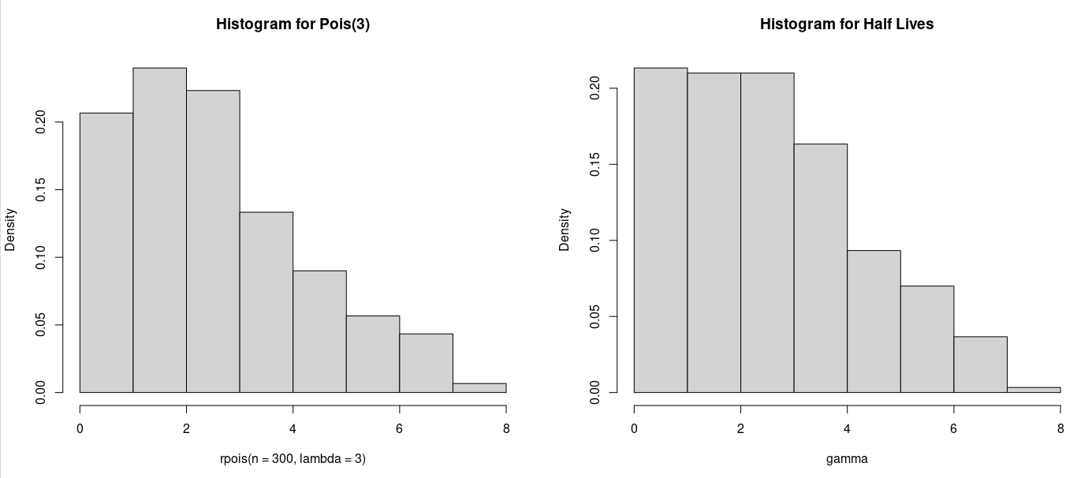

I think these are not similar, while they both follow a general half-life distribution Pois have an increase to decline while the Half Life graph starts high and incrementally falls.

The Pois histogram implies some sort of curve before 0 while Half live starts at a constant then decreases down.

Appendix:

Q1a)

roul = read.table ("roulette.txt", header =F)

roulette = roul$V1

roulette

fivenum(roulette)

##five num summary displays five num summaray

##or we can use summary like the pdf request

summary(roulette)

Q1b)

##calculating the IQR range

##inner fences of the IQR

summary(roulette)[2]-1.5*IQR(roulette)*

*summary(roulette)[5]+1.5*IQR(roulette)

#outer fences of the IQR

summary(roulette)[2]-3*IQR(roulette)*

*summary(roulette)[5]+3*IQR(roulette)

Q1C)

#gennerating a box plot from roullete data

boxplot(roulette,main="Box Plot for roulette Data",ylab="Maximum Capital",horizontal = T)

Q2A)

#start of question 2

Delta = read.table("gamma.txt", header=F)

gamma = Delta$V1

##calculating the question of 0, 1 , 2, ..8

table(gamma)

Q2B)

#calculate the sample mean and sample variance

mean(gamma)

var(gamma)

Q2C)

##construct a probablity histogram according to lamba = 3

par(mfrow=c(1,2))

hist(rpois(n=300, lambda=3), freq=F, breaks=10, main="Histogram for Pois(3)")

hist(gamma, freq=F, breaks=10, main="Histogram for Half Lives")